**What Is Java? A Beginner’s Guide to Java and Its Evolution**

**Java** is a general-purpose, concurrent, object-oriented, class-based, and the runtime environment (JRE) which consists of **JVM** which is the cornerstone of the Java platform.

, I would be covering following topics:

* What is Java?
* History of Java
* What is Java used for?
* Features of Java
* Components in Java

## ****What is Java used for?****



## ****History of Java****

Java is a programming language developed by **James** **Gosling** with other team members named **Mike Sheridan** and **Patrick Naughton** also called as **Green Team** in **1995** for **Sun Microsystems** for digital devices such as set-top boxes, televisions etc. Now, let us see in detail what is Java.

## ****What is Java?****

It is an object-oriented language similar to C++, but with advanced and simplified features. Java is **free to access** and can **run** on **all platforms**.

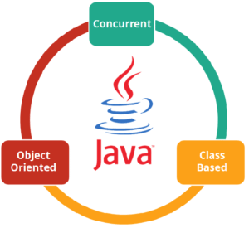

Java is: –

* **Concurrent** where you can execute many statements instead of sequentially executing it.
* **Class-based** and an **object-oriented** programming language.
* **Independent** programming language that follows the logic of “**Write once, Run anywhere**” i.e. the compiled code can run on all platforms which supports java.
* In simple words, it is a computing platform where you can develop applications.

## ****Features of Java****

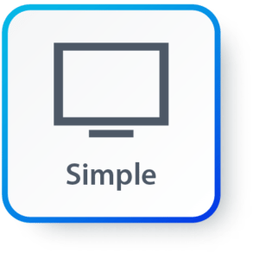**Simple:**Java has made life easier by removing all the complexities such as pointers, operator overloading as you see in C++ or any other programming language.

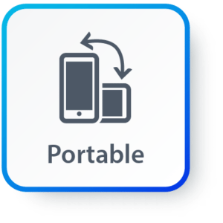

**Portable:**Java is platform independent which means that any application written on one platform can be easily ported to another platform.

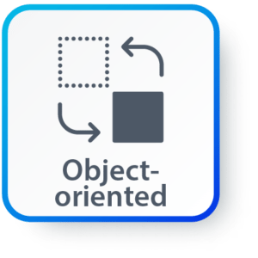**Object-oriented:**Everything is considered to be an “**object**” which possess some state, behavior and all the operations are performed using these objects.

**Secured:**All the code is converted in **bytecode** after compilation, which is not readable by a human. and java does not use an explicit pointer and run the programs inside the sandbox to prevent any activities from untrusted sources. It enables to develop virus-free, tamper-free systems/applications.

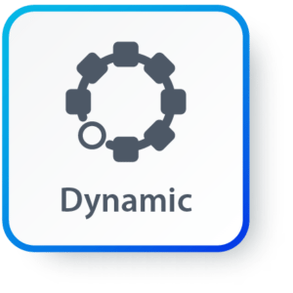**Dynamic:**It has the ability to adapt to an evolving environment which supports dynamic memory allocation due to which memory wastage is reduced and performance of the application is increased.

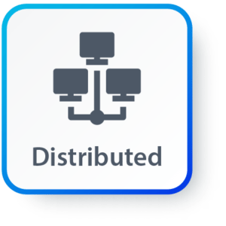**Distributed:**Java provides a feature which helps to create distributed applications. Using Remote Method Invocation (RMI), a program can invoke a method of another program across a network and get the output. You can access files by calling the methods from any machine on the internet.

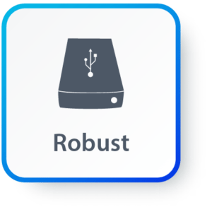**Robust:**Java has a strong memory management system. It helps in eliminating error as it checks the code during compile and runtime.

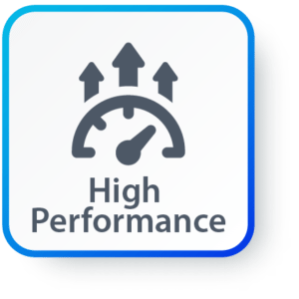**High Performance:**Java achieves high performance through the use of bytecode which can be easily translated into native machine code. With the use of JIT (Just-In-Time) compilers, Java enables high performance.

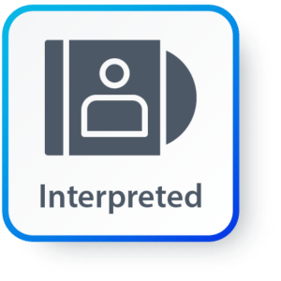**Interpreted:** Java is compiled to bytecodes, which are interpreted by a Java run-time environment.

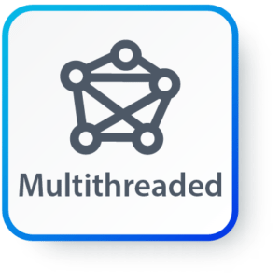**Multithreaded:** Java supports multiple threads of execution (a.k.a., lightweight processes), including a set of synchronization primitives. This makes programming with threads much easier.

## ****Components in Java****

**JVM (Java Virtual Machine)**

It is an abstract machine. It is a specification that provides a run-time environment in which Java bytecode can be executed. It follows three notations:

* **Specification**: It is a document that describes the implementation of the Java virtual machine. It is provided by Sun and other companies.
* **Implementation**: It is a program that meets the requirements of JVM specification.
* **Runtime Instance**: An instance of JVM is created whenever you write a java command on the command prompt and run the class.

**JRE (Java Runtime Environment)**

JRE refers to a runtime environment in which Java bytecode can be executed. It implements the JVM (Java Virtual Machine) and provides all the class libraries and other support files that JVM uses at runtime. So JRE is a software package that contains what is required to run a Java program. Basically, it’s an implementation of the JVM which physically exists.

**JDK(Java Development Kit)**

It is the tool necessary to:-

* Compile
* Document
* Package Java programs.

The JDK completely includes JRE which contains tools for Java programmers. The Java Development Kit is provided free of charge. Along with JRE, it includes an interpreter/loader, a compiler (javac), an archiver (jar), a documentation generator (Javadoc) and other tools needed in Java development. In short, it contains JRE + development tools.

**JIT (Just in time )**

It Converts .class to binary Format. It does Following

1.Reads code line by line.

2.Excutes code Line by line

3.Translate from .class to binary.

**RTE (Runtime Error / Exception )**

It’s a java program will execute line by line from left to right.

## ****Hello World Program****

First of all, I will give you a simple overview of how a Java program looks like. In the below code, I have created a class – MyFirstJavaProgram and printed “Hello World”. Go ahead and try to execute the below example in your Eclipse IDE. Do not worry, we will discuss about Java class in a while.

|  |  |
| --- | --- |
|  | public class MyFirstJavaProgram {         public static void main(String[] args)     {      System.out.println("Hello World");     }  } |

Next, let us understand different member variables in Java.